Příloha 3:

NAME: ……………………………….

(usually, often, sometimes, never, very often)

BREAKFAST:

SNACK:

LUNCH:

SNACK:

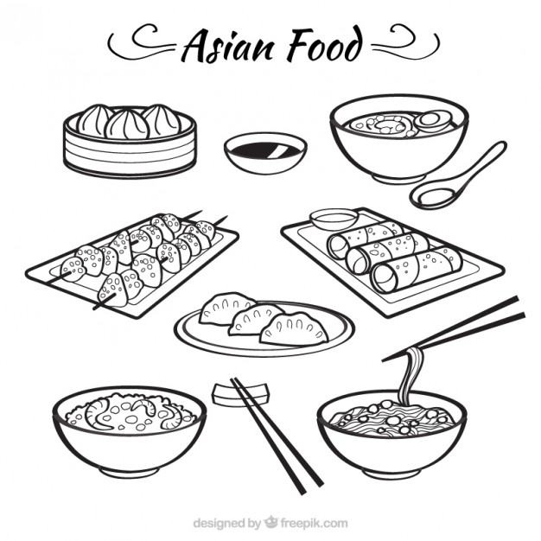
DINNER:

NAME: ……………………………….

(usually, often, sometimes, never, very often)

BREAKFAST:

SNACK:

LUNCH:

SNACK:

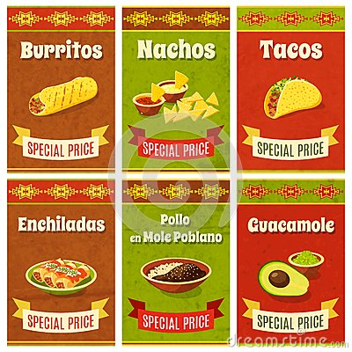
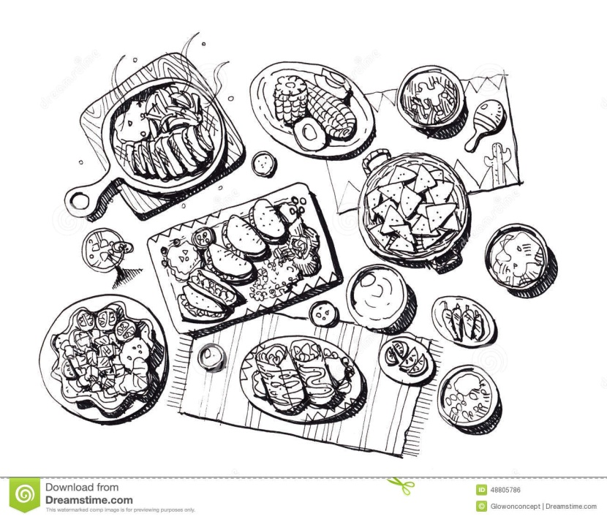
DINNER:

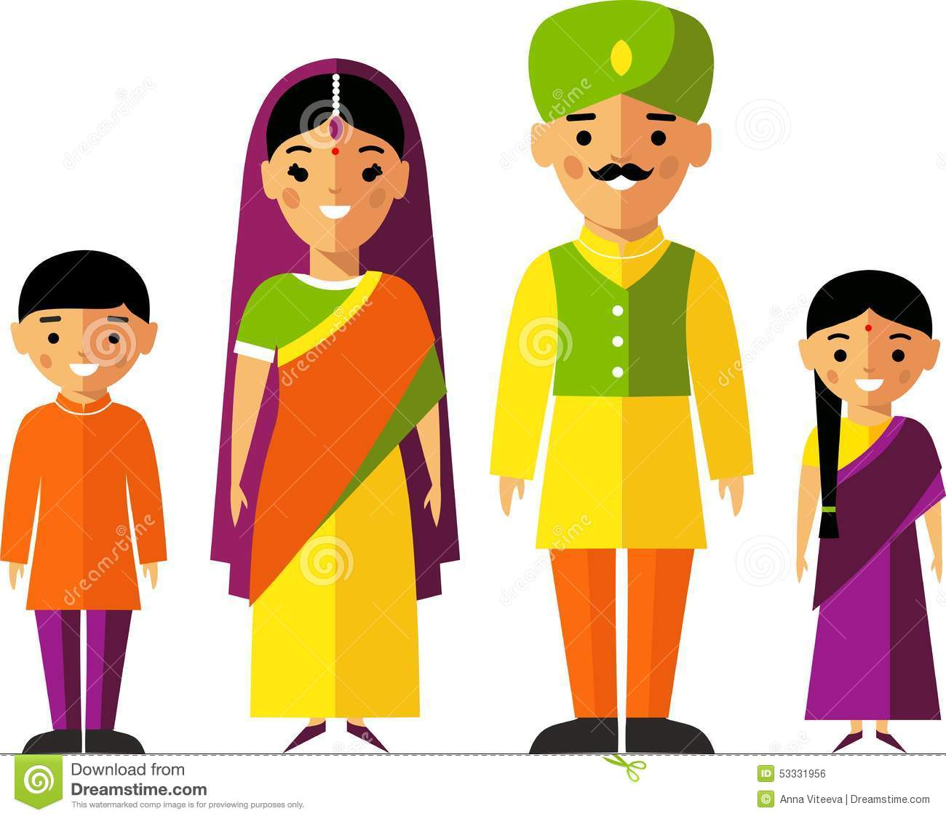
NAME: ……………………………….

(usually, often, sometimes, never, very often)

BREAKFAST:

SNACK:

LUNCH:

SNACK:

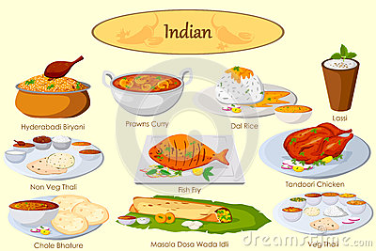
DINNER:

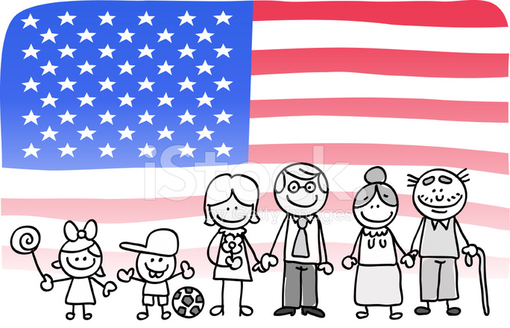
NAME: ……………………………….

(usually, often, sometimes, never, very often)

BREAKFAST:

SNACK:

LUNCH:

SNACK:

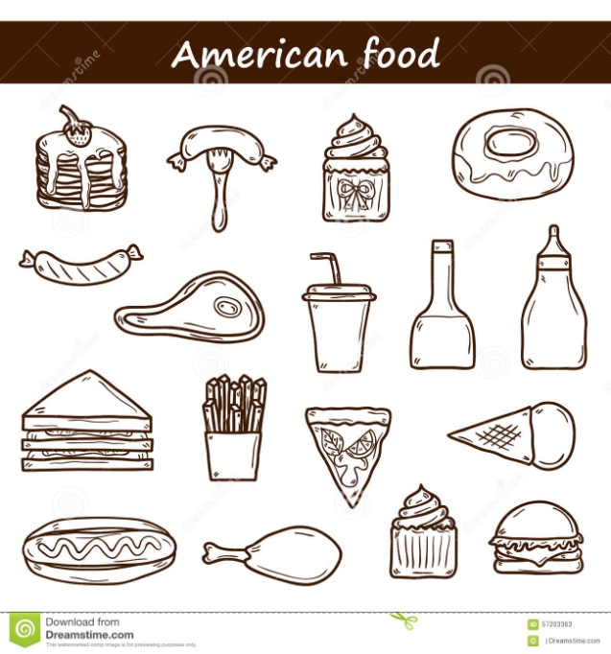
DINNER:

