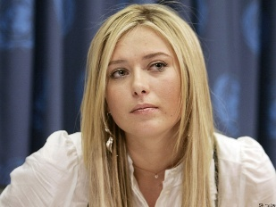
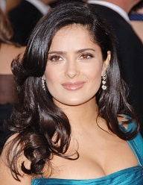
Avril Lavigne Maria Sharapova Salma Hayek
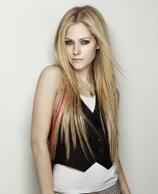
She is from Canada She is from ………………. She is from Mexico
She is …………………. She is Russian She is …………
She speaks ………………….. She speaks ………………. She speaks ……..

