Hi! My name is ………………….. I am a singer. I was born in Melbourne. It is the second biggest city in my country. I often go to our capital city – Canberra. There are beautiful places and many nice restaurants. Some people eat kangaroo, emu and crocodile meat, but I do not like this kind of meat. I love eating fish; it is very typical of our country. A lot of people eat fish and chips for lunch. My favourite desserts are pavlova and ANZAC biscuits. I like visiting Sydney. There is a beautiful Opera House and magical Royal Botanic Gardens, where you can relax. People who like camping often go to Purnululu National Park. You can see many animals there, for example dingo, donkey, emu or cockatoo.

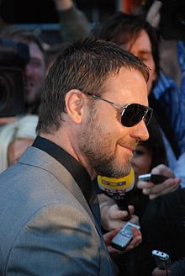
Hi! My name is ………………….. I am an actor. I was born in Wellington. It is our capital city. Our biggest city is Auckland. There is the Sky Tower, which is 328 meters high. There live about 1,413,700 people in Auckland. I like going to Kaikoura. It is a small town by the sea. You can often see seals, dolphins, whales and albatrosses there. I often eat meat pies with a lot of vegetables for dinner. People also like eating fish and chips. I do not like desserts, but our national dessert is pavlova. I like going to Abel Tasman National Park. You go there by boat or a small plane. My favourite place is the Bay of Islands. There are 144 islands with great sandy beaches.

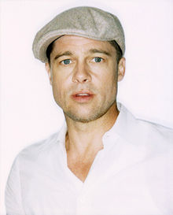
Hi! My name is ……………….. I am an actor. I was born in Shawnee. This town is in Oklahoma, which is one of 50 states of my country. The capital city is Washington, D.C., where you can find the White House. I think San Francisco is the most beautiful city. There is the Golden Great Bridge. I do not like New York much because there is a lot of smog, but I think that Manhattan and the Statue of Liberty are important parts of my country. The Grand Canyon and the Yellowstone National park are great places to see. Many people in my country love hot dogs and hamburgers but I prefer fried chicken with French fries. My children love doughnuts and cupcakes.

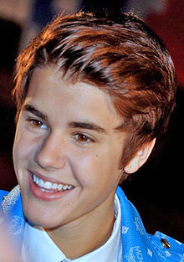
Hi! My name is ……………………...... I am a singer. I was born in Ontario. It is one of the ten provinces of my country. There are also three territories. Our capital city is Ottawa but more people live in Toronto. People often eat poutine – French fries, topped with sauce and cheese, but I do not like it. I love “mac and cheese” – macaroni and Cheddar cheese. My grandma often bakes butter tarts – I love those with coconut. People in my country love ice-hockey. There are great teams in Ottawa, Toronto or Montreal. My favourite team is Vancouver Giants. In winter I often go skiing to Whistler. I also went camping to the Banff National Park last summer.

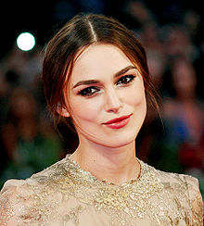
Hi! My name is …………………….. I am an actress. I was born in Teddington. Teddington is a part of London, the capital city of my country. I love shopping in London, but sometimes I just go for a walk to Hyde Park or Kensington Gardens. I do not like our typical breakfast much because I do not like bacon. I prefer pancakes with fruit or muffins. My mum is a great cook. Her Sunday roast (roasted meat, mashed potatoes, vegetables and Yorkshire pudding) is the best! People in my country also like fish and chips or shepherd´s pie. My parents wanted me to go to some famous university. They are in Oxford and Cambridge. I wanted to become an actress. In summer I often go to the Lake District. There is the highest mountain, Scaffel Peak, and the longest lake, Windermere.

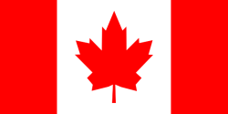
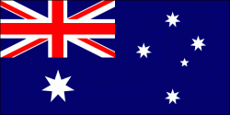

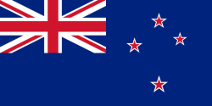
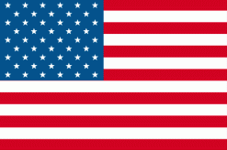

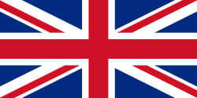

Where in the world?
Country | Flag | Capital city | Typical Food | Things to see
Where in the world?
Country | Flag | Capital city | Typical Food | Things to see
Where in the world?
Country | Flag | Capital city | Typical Food | Things to see
Where in the world?
Country | Flag | Capital city | Typical Food | Things to see

Where in the world?
Country | Flag | Capital city | Typical Food | Things to see

Where in the world?
Country | Flag | Capital city | Typical Food | Things to see

Where in the world?
Country | Flag | Capital city | Typical Food | Things to see

Rozdělit do skupin po 2. Po třídě rozmístit papíry s informace o různých zemích. Žáci mají za úkol najít informace ke své zemi. První skupina vyhrává.

Have you ever been to…..?
Name | Great Britain | Canada | USA | New Zealand
Have you ever been to…..?
Name | Great Britain | Canada | USA | New Zealand
Have you ever been to…..?
Name | Great Britain | Canada | USA | New Zealand

Have you ever been to…..?
Name | Great Britain | Canada | USA | New Zealand
Have you ever been to…..?
Name | Great Britain | Canada | USA | New Zealand
Have you ever been to…..?
Name | Great Britain | Canada | USA | New Zealand

Have you ever been to…..?
Name | Great Britain | Canada | USA | New Zealand
Have you ever been to…..?
Name | Great Britain | Canada | USA | New Zealand

Have you ever been to…..?
Name | Great Britain | Canada | USA | New Zealand

Have you ever been to…..?
Name | Great Britain | Canada | USA | New Zealand
Have you ever been to…..?
Name | Great Britain | Canada | USA | New Zealand
Have you ever been to…..?
Name | Great Britain | Canada | USA | New Zealand

Speaking Activity:
Každý žák dostane tuto tabulku. Od 5 svých spolužáků má za úkol zjistit, které země navštívili.

